**Filter Classifications**

Electronic *filters* can often by applied to sensor signals to remove unwanted frequency components. Filters are classified based on the range of frequencies passed through. Four common types of filters are:

#### *Low-pass* – Only frequencies below a selected cutoff frequency, *fc* , are passed

#### *High-pass* – Only frequencies above a selected cutoff frequency, *fc* , are passed

#### *Bandpass* – Only frequencies above cutoff frequency, *fc1 ,* and below *fc2* are passed

#### *Notch* – Only frequencies below cutoff frequency, *fc1 ,* and above *fc2* are passed

* .

**Filter Behavior – Ideal (not real! No filter can obtain this sharp cutoff)**

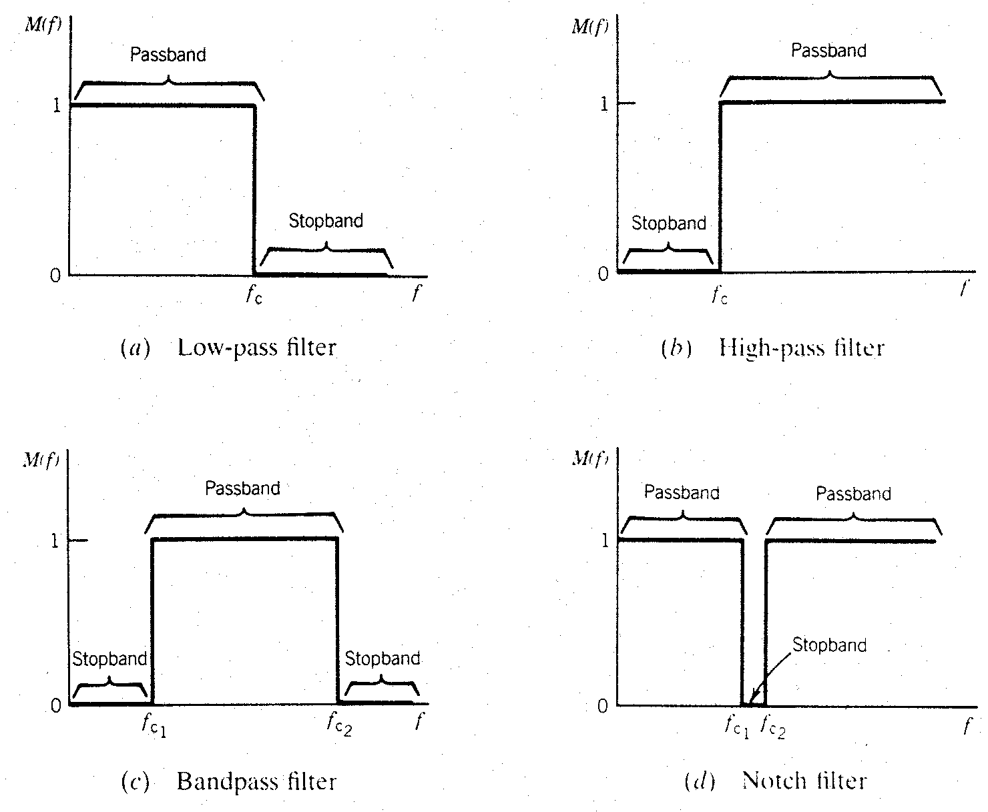

Figure from Theory and Design of Mechanical Measurements, R.S. Figliola and D.E. Beasley, 1991.

**Real Filters**

The frequency response characteristics of an actual “real” filter can only approximate the ideal responses illustrated in the previous figure.

In particular, real filters display a *roll-off* at a limiting frequency instead of a sharp cut-off. The figure below demonstrates a real response from a low pass filter, compare this with the ideal low pass filter in the prior figure.

fc

1

0

Frequency

Gain = Vout/Vin

Roll-off Region

Note: The cutoff frequency is often specified to be where the gain is –3 dB (the output is 70.8% of the input).

# RC & RL Filters

Good results for low cost measurement systems, for example in an application where one wants to minimize noise at high frequencies, can often be obtained by the use of simple RC and RL circuits. See the Table below for mathematical expressions of the ratio of output voltage to input voltage as a function of the frequency of the input voltage.

*Note:*

The cutoff frequency for a filter built from an RC circuit is determined by *fcutoff =* 1 / (2π RC) Hz.

At the cutoff frequency, the response Vout equals to 0.707 Vin, this is the -3dB point.

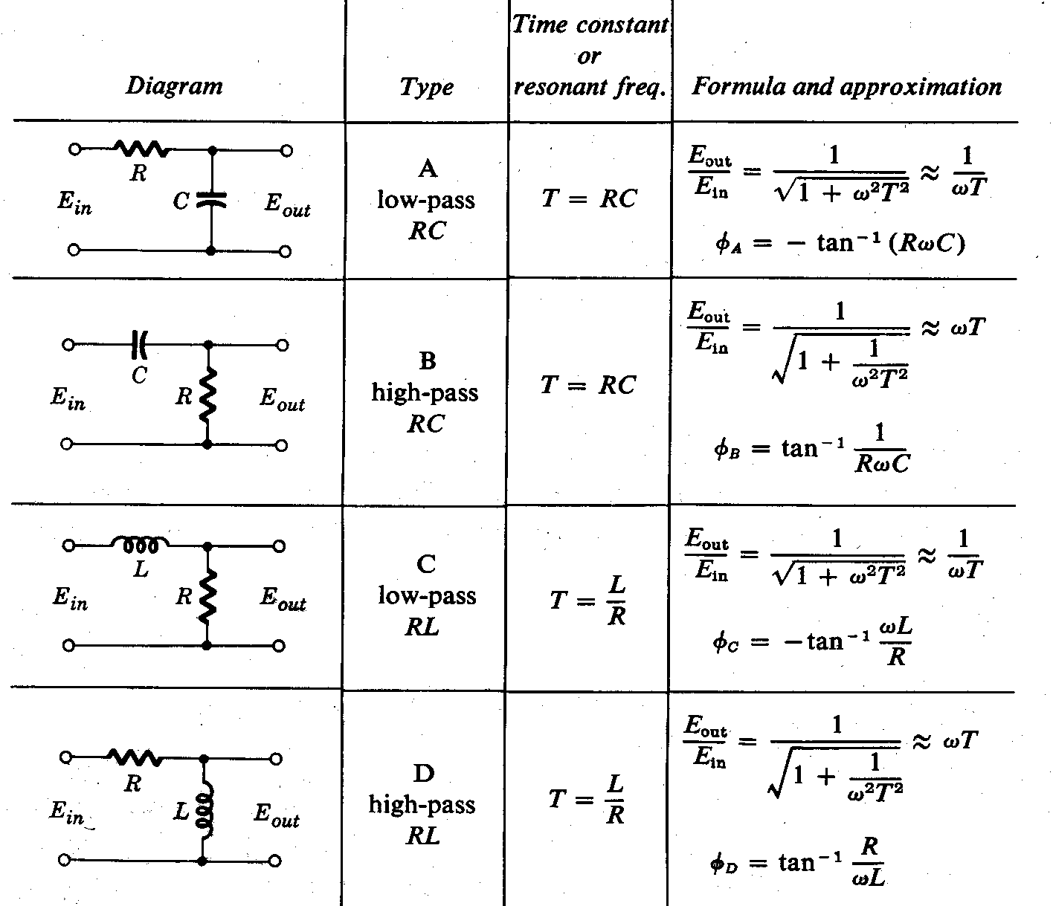**A little bit of math… and a little bit of MATLAB**

Table from “Experimental Methods for Engineers,” J.P. Holman, 1966, p. 132.

The differential equation for a Low-Pass RC circuit is



*What is time constant, τ?*

And when we consider an input voltage to the circuit of vs(t) = A sin(ωt), a sinusoidal input,

The output voltage will be … (applying our best differential equation solving!)

*Do you see a term in the solution that will become very small as time increases beyond 5 tau?*



Plotting the time traces for input (blue) and output (green) from MATLAB…

For A = 1, ω = 1000, R = 100kΩ, and C = 0.022μF

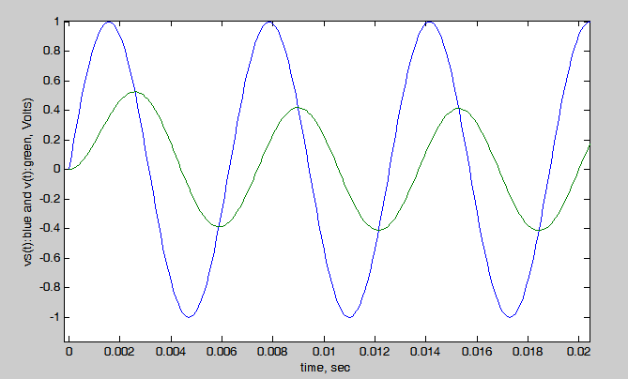

Another way to examine the behavior of the RC filter is to see what happens for **all** values of input frequency, ω. Looking ahead to ME3050 and ME3060, you will learn about *Transfer Functions and Bode plots.*

omega=1000;

A=1;

R=100e3;

C=0.022e-6;

tau=R*C;

fc = 1/tau

t = 0:0.0001:1;

vs=A*sin(omega*t);

v=( (A*omega*tau) / (1+omega^2*tau^2) )*(exp(-t/tau) - cos(omega*t) + (1/(omega*tau))*sin(omega*t));

plot(t,vs,t,v);

xlabel('time, sec'),ylabel('vs(t):blue and v(t):green, Volts)')

The *transfer function,* in terms of the Laplace transform, s, for this differential equation is

**

and if we let the Laplace variable, s, be equal to s = jω in order to see the effect of driving the system at different frequencies, we get a complex function,

$$T(jω)=\frac{1}{τ(jω)+1}$$

Now we consider the magnitude and phase of the complex transfer function



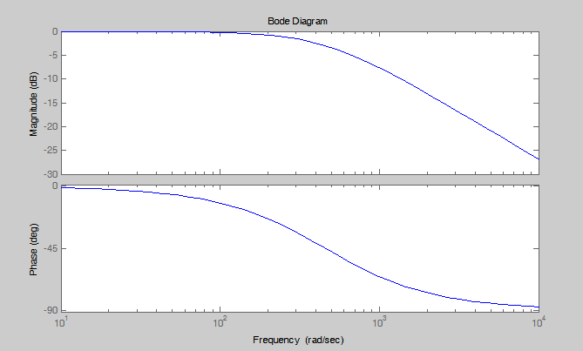

These values can be plotted in MATLAB using the *bode* function, which will show the GAIN, M in untis of dB. Note a 0 value of dB is equivalent to 1, so this is showing a low pass filter behavior.

